Advanced Signal Processing - Challenge

Variable data defintion:

**CCU**: The acronym CCU sometimes stands for a **critical care unit.** When used this way, critical care and intensive care have the same meaning and offer the same type of care. In this instance, CCU and ICU can be used interchangeably.

**CSRU:**

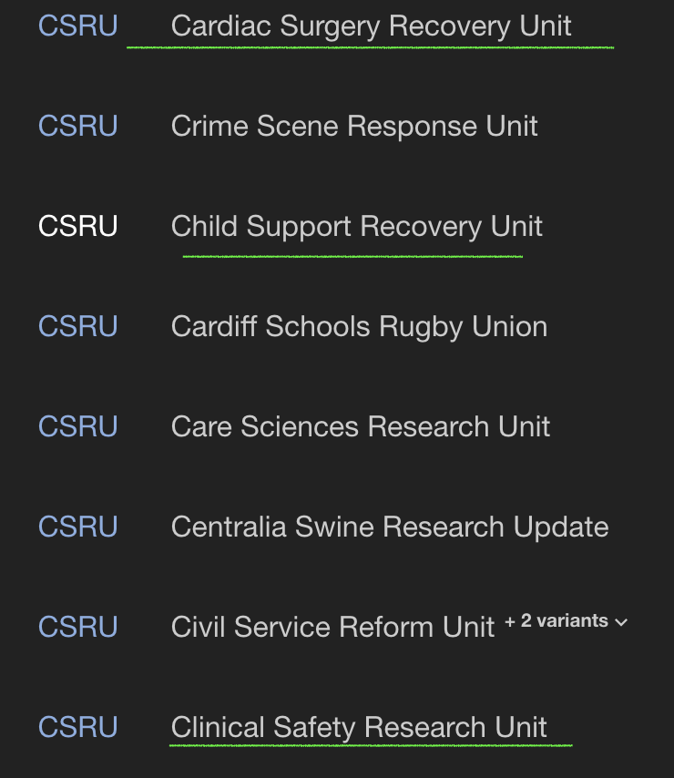

S**ICU: The Surgical Intensive Care Unit (SICU)** is the multispecialty medical care center for critically ill patients who require surgery or are recovering from surgery.